BARLEY FLOUR

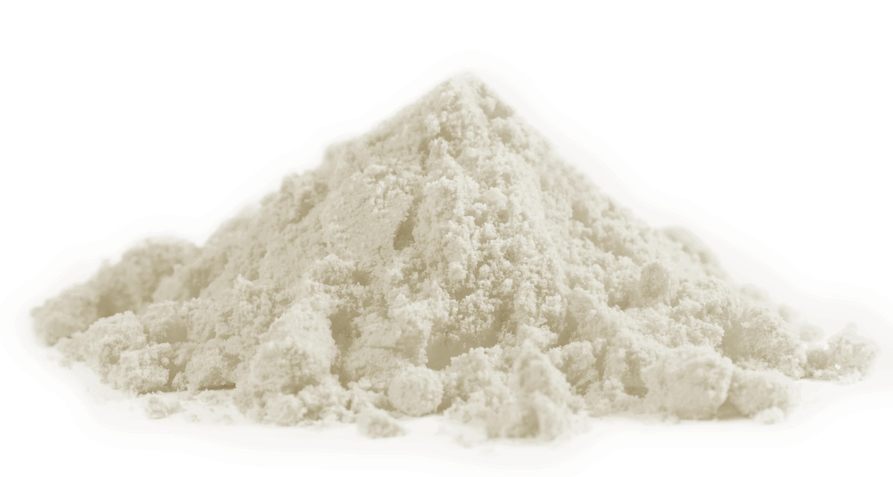

INGREDIENT | ORIGIN | CERTIFICATION
Barley | Italy: Marche, Toscana, Umbria | “QM” Qualità dalle MARCHE;  Reg (CE) 848/2018 (BIO)

ORGANOLEPTIC CHARACTERISTIC OF THE PRODUCT
PARAMETER | DEFINITION
Color | Off white
Smell | Characteristic
Taste | Characteristic
Aspect | Characteristic

CHEMICAL CHARCTERISTICS
PARAMETER | UNIT MEASUREMENT | REFERENCE VALUE
Humidiy | % | Max 14
Plant protection products | mg/kg | < 70% LMR (Reg 396/2005)
Heavy metals (Pd-Cd) | mg/kg | Reg (CE) 1881/2006

PHISICAL / PRODUCT CHARACTERISTICS
DEFECTIVENESS PER INGREDIENT | UNIT MEASURAMENT | REFERENCE VALUE
Foreign materials | % | Absent
Allergens | Gluten

HEALTH AND HYGIENE CHARACTERISTICS
PARAMETER |  | UNIT MEASUREMENT | REFERENCE VALUE
Whole insects (larvae,nymphs or adults) |  | n/g | Absent
Rodent hair or frangments thereof |  | n/g | Absent
Insect frangments |  | n/g | Absent
Other frangments |  | n/g | Absent
MICROBIOLOGICAL CHARACTERISTICS
PARAMETER | UNIT MEASURAMENT |  | REFERENCE VALUE
Mesophilic bacterial charge | ufc/g |  | <500.000
Yeast and moulds | ufc/g |  | < 5.000
Escherichia coli | ufc/g |  | <10
Salmonella | Present / Absent in 25 g |  | Absent
Listeria m. | Present / Absent in 25 g |  | Absent
Deossinivalenolo | μg/kg |  | 750
Zearalenone | μg/kg |  | 75
Ocratossina A | μg/kg |  | 3
Aflatossine (B1+B2+G1+G2) | μg/kg |  | 4

NUTRITIONAL VALUE
PARAMETER | UNIT MEASURAMENT | AVERAGE VALUE/100g OF RAW PRODUCT
Energy | KJ- Kcal | 1493 – 357
Fat | g | 1,9
Of which satured fatty acids | g | 0,3
Carbohydrates | g | 79,3
Of which sugar | g | 0,8
Fibre | g | 10,1
Protein | g | 10,6
Salt | g | 0,01

Production plant: Taverne snc, Serravalle di Chienti (MC).

Weight: the product is packed in sizes of 250 g, 400 g, 500 g, 1 kg, 5 kg, 15 kg, 25 kg, big-bag.

Minimum shelf life: 12 months.

Allergens contained and possible cross-contamination: May contain Traces of "Cereals containing gluten".

GMOs: the product is free from contamination by Genetically Modified Organisms.

Tips for proper storage: store in a cool and dry place away from light and heat sources. Once opened, the package should be stored at room temperature, avoiding leaving the package open.

